**Deons Longitudinal Network Analysis**

#Load required packages

library(bootnet)

library(networktools)

library(NetworkComparisonTest)

library(qgraph)

{r echo=FALSE, warning=FALSE, error=FALSE}

Part 1: First Time point

#Load data of first network "time_point_1" (I just used haven)

#Assign names to the nodes in the first network

names1 <- c("BSMAS_1", "BSMAS_2", "BSMAS_3", "BSMAS_4", "BSMAS_5", "BSMAS_6", "Depression1", "Anxiety1", "Stress1")

#Estimate network using default methods

network1 <- estimateNetwork(Time_point_1, default="EBICglasso")  
  
#group DASS and BSMAS nodes

groups1=list("SMA"=c(1:6), "Distress"=c(7:9))

#Estimate Network Stability by bootstrapping network

b1 <- bootnet(network1, boots=1000, statistics=c("strength", "expectedInfluence", "betweenness", "closeness", "edge"))

b2 <- bootnet(network1, boots=1000, type="case", statistics=c("strength", "expectedInfluence", "betweenness", "closeness", "edge"))

#Get centrality stability coefficient

corStability(b2)

Maximum drop proportions to retain correlation of 0.7 in at least 95% of the samples:

betweenness: 0.05 (CS-coefficient is lowest level tested)

- For more accuracy, run bootnet(..., caseMin = 0, caseMax = 0.128)

closeness: 0.128

- For more accuracy, run bootnet(..., caseMin = 0.05, caseMax = 0.206)

edge: 0.749 (CS-coefficient is highest level tested)

- For more accuracy, run bootnet(..., caseMin = 0.673, caseMax = 1)

expectedInfluence: 0.595

- For more accuracy, run bootnet(..., caseMin = 0.517, caseMax = 0.673)

strength: 0.361

- For more accuracy, run bootnet(..., caseMin = 0.284, caseMax = 0.439)

Accuracy can also be increased by increasing both 'nBoots' and 'caseN'.

#Save centrality stability graphs

pdf("CentrStability1.pdf")

plot(b2)

dev.off()

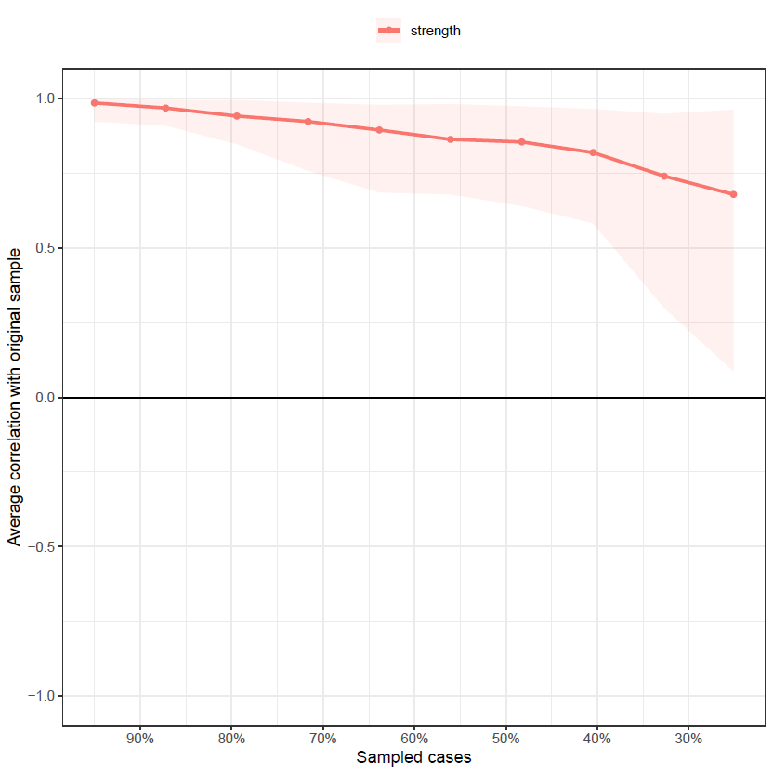

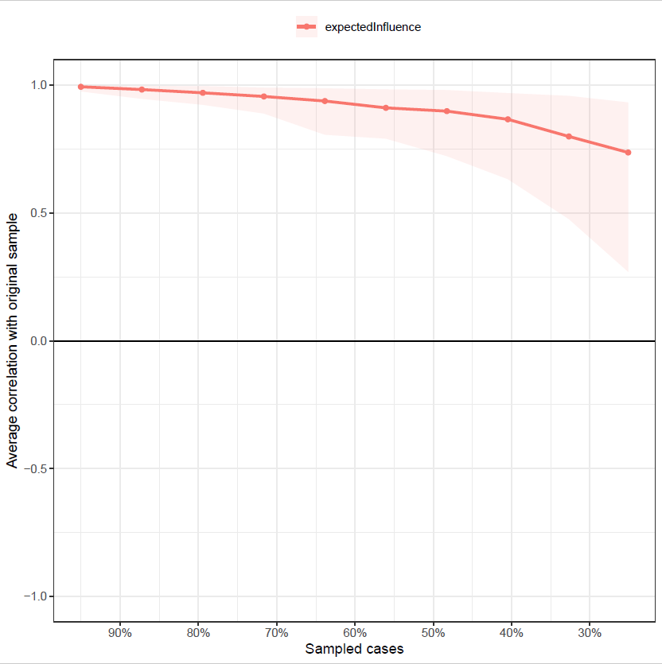pdf("ExpectStability1.pdf")

plot(b2, “expectedInfluence”)

dev.off()

pdf("betweenStability1.pdf")

plot(b2, "betweenness")  
dev.off()

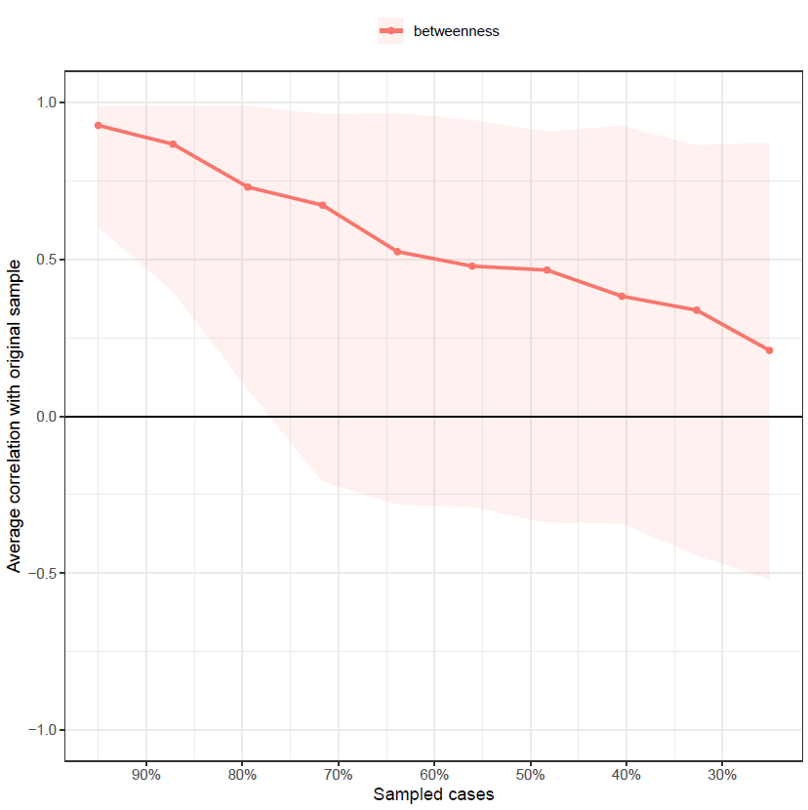

pdf("closeStability1.pdf")

plot(b2, "closeness")

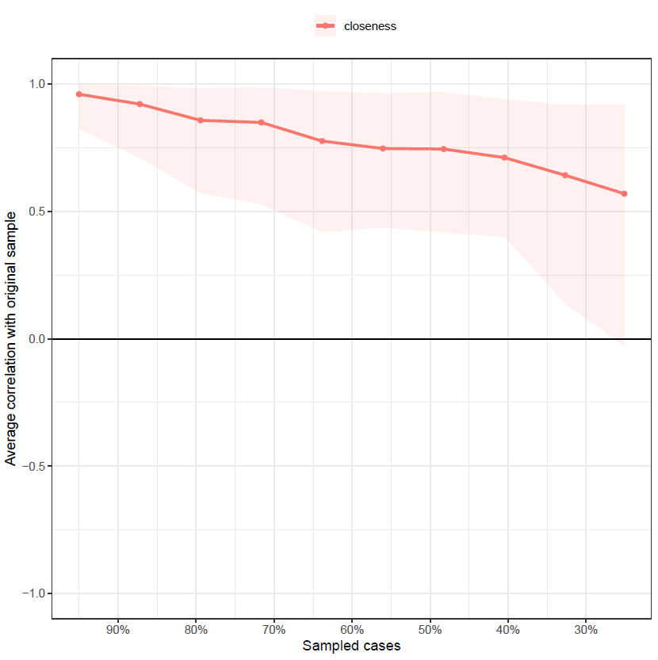dev.off()

#Strength Centrality Diff Test, saved as pdf

pdf("CentralityDifference1.pdf")

plot(b1, "strength", order="sample", labels=TRUE)

dev.off()

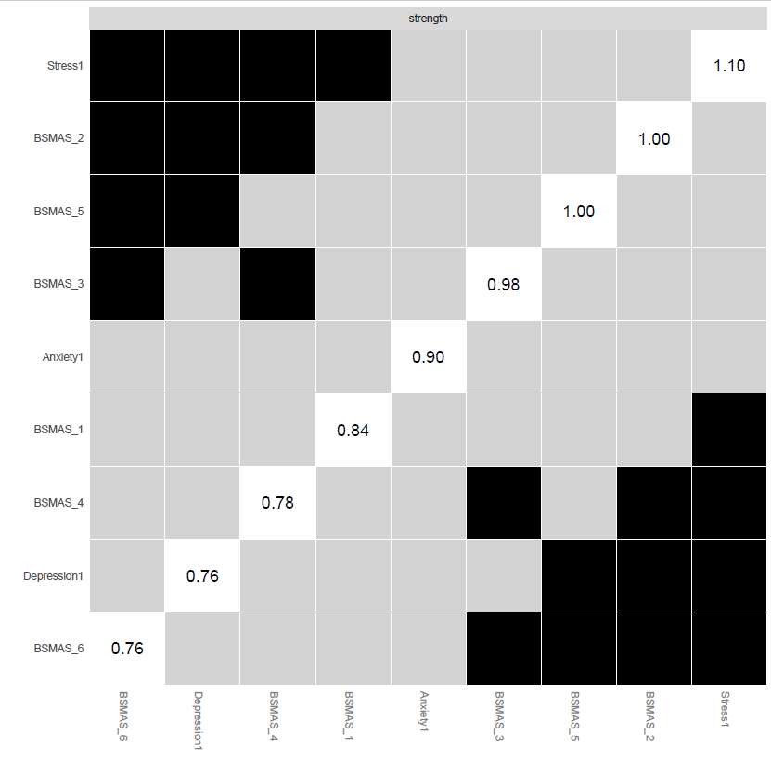

#Expected Influence Centrality Diff Test, saved as pdf

pdf("ExpectedDifference1.pdf")

plot(b1, "expectedInfluence", order="sample", labels=TRUE)

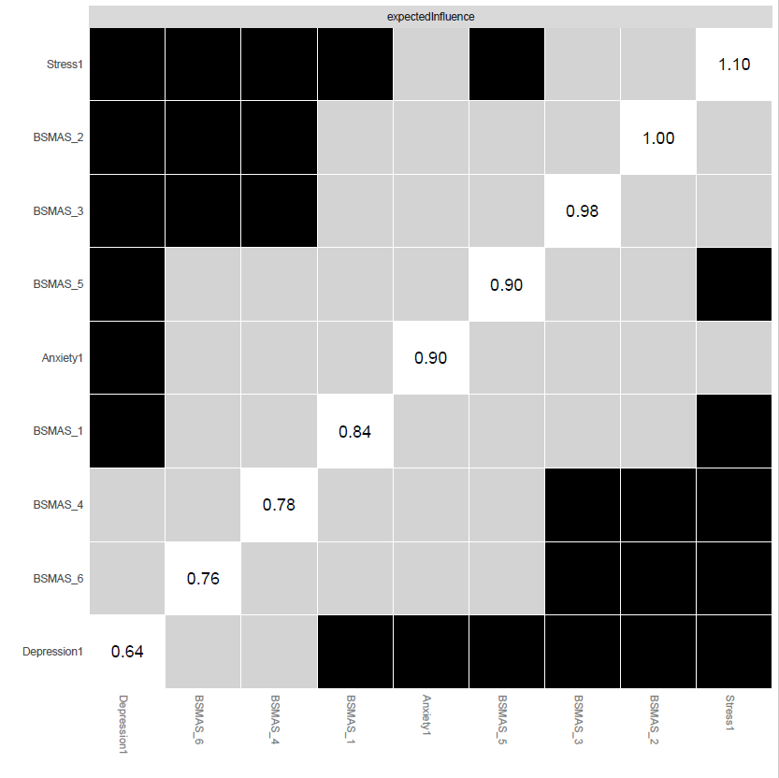dev.off()

#Edge Stability Graph saved as pdf

pdf("EdgeStability1.pdf")

plot(b1, labels = FALSE, order = "sample")

dev.off()

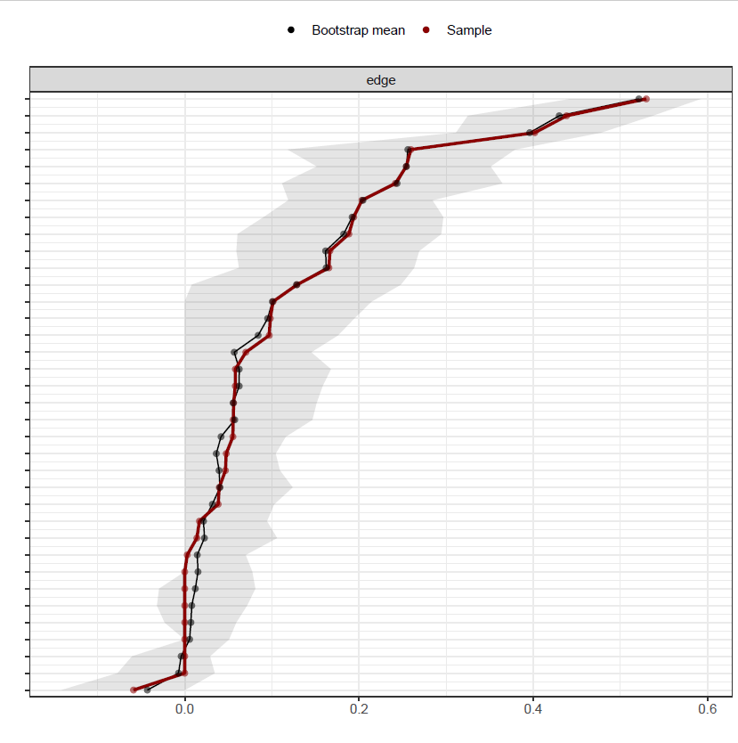

#Edge weights stability test saved as pdf

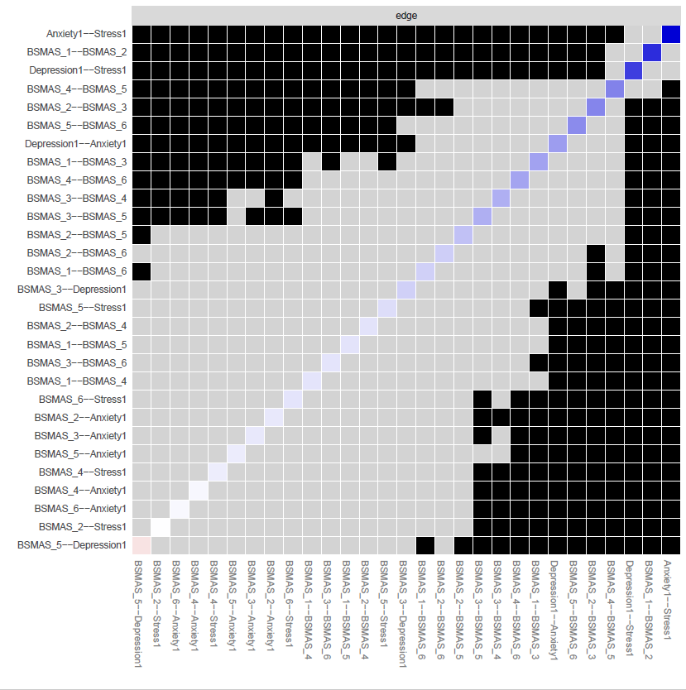pdf("EdgeDifftest1.pdf")

plot(b1, "edge", plot="difference", onlyNonZero=TRUE, order = "sample")

dev.off()

#create strength/EI centrality plots and save as pdf

pdf("EDPlot1.pdf", width=5)

c1 <- centralityPlot(network1, include = c("ExpectedInfluence"), orderBy ="default")

dev.off()

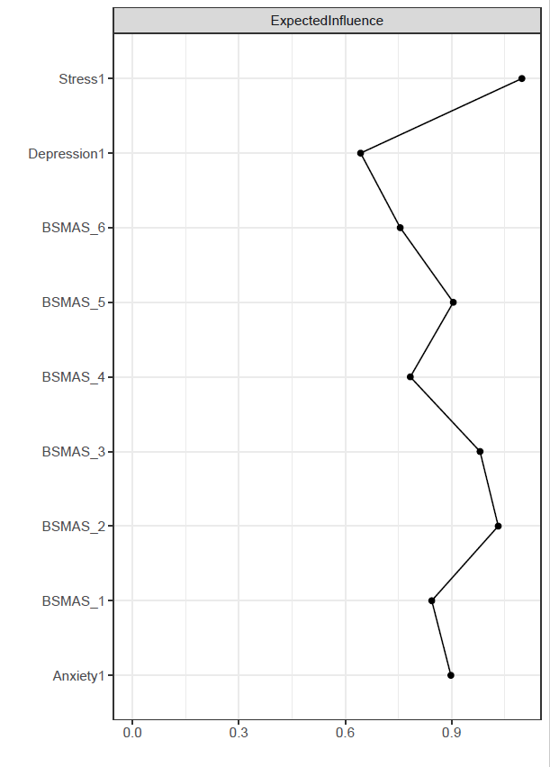

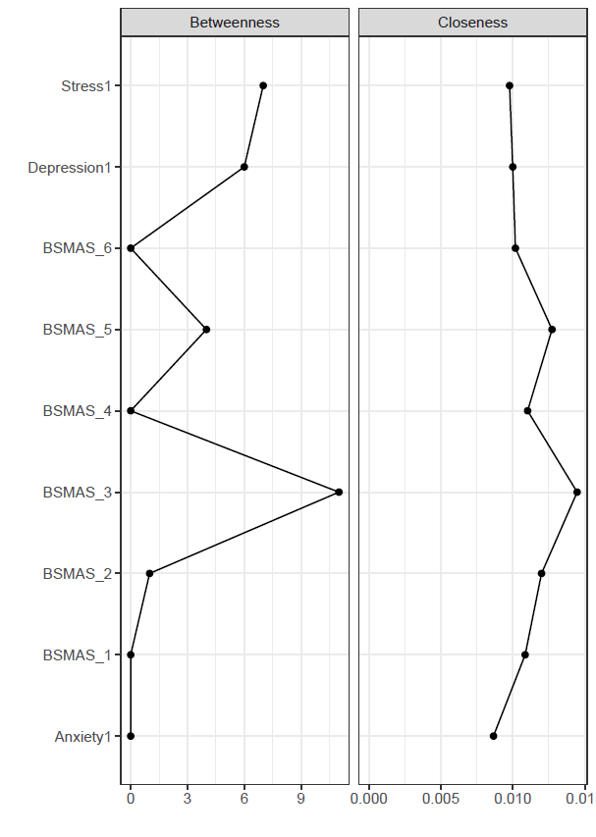pdf("CentralityPlot1.pdf", width=5)

c2 <- centralityPlot(network1, include = c("Betweenness", "Closeness"), orderBy ="default")

dev.off()

#Setdirectory to save files into

setwd("C:/Users/Deon Tullett-Prado/Documents/R objects")

#create a plot featuring these groups and make it a pdf

pdf("plot1.pdf")

plot1 <- plot(network1, layout="spring", vsize=6, border.color="black", groups=groups1, color=c('lightblue', 'orange'))

dev.off()

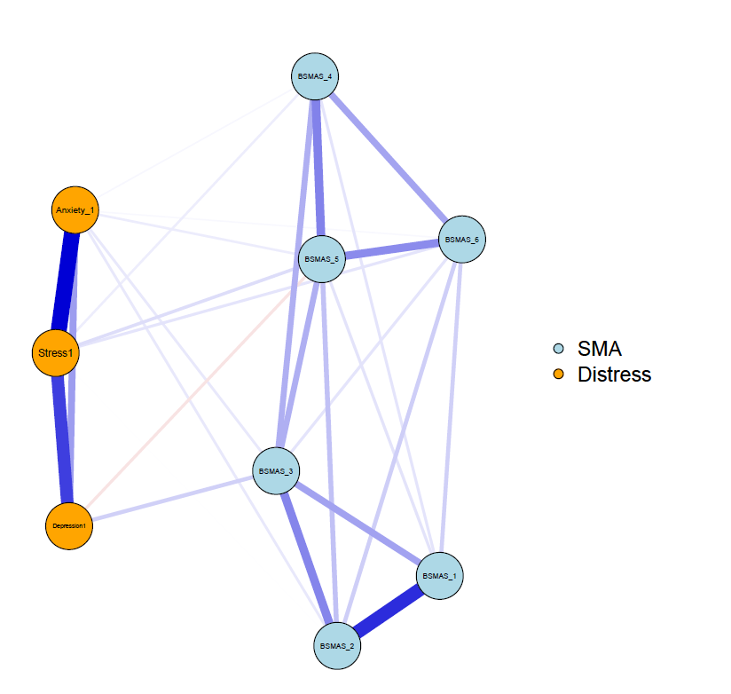

#save centrality values as a excel file

Centrality1 <- centralityTable(network1)

write.csv(Centrality1, "Centrality1.csv")

|  |  |  |  |  |  |
| --- | --- | --- | --- | --- | --- |
|  | graph | type | node | measure | value |
| 1 | graph 1 | NA | BSMAS_1 | Betweenness | -0.800704854 |
| 2 | graph 1 | NA | BSMAS_2 | Betweenness | -0.552210244 |
| 3 | graph 1 | NA | BSMAS_3 | Betweenness | 1.932735855 |
| 4 | graph 1 | NA | BSMAS_4 | Betweenness | -0.800704854 |
| 5 | graph 1 | NA | BSMAS_5 | Betweenness | 0.193273586 |
| 6 | graph 1 | NA | BSMAS_6 | Betweenness | -0.800704854 |
| 7 | graph 1 | NA | Depression1 | Betweenness | 0.690262805 |
| 8 | graph 1 | NA | Anxiety1 | Betweenness | -0.800704854 |
| 9 | graph 1 | NA | Stress1 | Betweenness | 0.938757415 |
| 10 | graph 1 | NA | BSMAS_1 | Closeness | -0.123704871 |
| 11 | graph 1 | NA | BSMAS_2 | Closeness | 0.523862546 |
| 12 | graph 1 | NA | BSMAS_3 | Closeness | 1.933348598 |
| 13 | graph 1 | NA | BSMAS_4 | Closeness | -0.027560104 |
| 14 | graph 1 | NA | BSMAS_5 | Closeness | 0.939289784 |
| 15 | graph 1 | NA | BSMAS_6 | Closeness | -0.509329003 |
| 16 | graph 1 | NA | Depression1 | Closeness | -0.615131936 |
| 17 | graph 1 | NA | Anxiety1 | Closeness | -1.37878727 |
| 18 | graph 1 | NA | Stress1 | Closeness | -0.741987743 |
| 19 | graph 1 | NA | BSMAS_1 | Strength | -0.494868377 |
| 20 | graph 1 | NA | BSMAS_2 | Strength | 0.951333878 |
| 21 | graph 1 | NA | BSMAS_3 | Strength | 0.555268641 |
| 22 | graph 1 | NA | BSMAS_4 | Strength | -0.961844621 |
| 23 | graph 1 | NA | BSMAS_5 | Strength | 0.880574905 |
| 24 | graph 1 | NA | BSMAS_6 | Strength | -1.181230452 |
| 25 | graph 1 | NA | Depression1 | Strength | -1.136171275 |
| 26 | graph 1 | NA | Anxiety1 | Strength | -0.078930391 |
| 27 | graph 1 | NA | Stress1 | Strength | 1.465867691 |
| 28 | graph 1 | NA | BSMAS_1 | ExpectedInfluence | -0.265724748 |
| 29 | graph 1 | NA | BSMAS_2 | ExpectedInfluence | 1.044674759 |
| 30 | graph 1 | NA | BSMAS_3 | ExpectedInfluence | 0.68580124 |
| 31 | graph 1 | NA | BSMAS_4 | ExpectedInfluence | -0.688850516 |
| 32 | graph 1 | NA | BSMAS_5 | ExpectedInfluence | 0.158527279 |
| 33 | graph 1 | NA | BSMAS_6 | ExpectedInfluence | -0.887635358 |
| 34 | graph 1 | NA | Depression1 | ExpectedInfluence | -1.66884036 |
| 35 | graph 1 | NA | Anxiety1 | ExpectedInfluence | 0.111155408 |
| 36 | graph 1 | NA | Stress1 | ExpectedInfluence | 1.510892297 |

#construct a partial correlation matrix

edges1<-getWmat(network1)

write.csv(edges1, "edges1.csv")

|  |  |  |  |  |  |  |  |  |  |
| --- | --- | --- | --- | --- | --- | --- | --- | --- | --- |
|  | BSMAS_1 | BSMAS_2 | BSMAS_3 | BSMAS_4 | BSMAS_5 | BSMAS_6 | Depression1 | Anxiety_1 | Stress1 |
| BSMAS_1 | 0 | 0.438238 | 0.193917 | 0.055641 | 0.05804 | 0.098153 | 0 | 0 | 0 |
| BSMAS_2 | 0.438238 | 0 | 0.254213 | 0.058124 | 0.12889 | 0.101438 | 0 | 0.047646 | 0.002858 |
| BSMAS_3 | 0.193917 | 0.254213 | 0 | 0.166602 | 0.165493 | 0.056109 | 0.096991 | 0.046755 | 0 |
| BSMAS_4 | 0.055641 | 0.058124 | 0.166602 | 0 | 0.259509 | 0.188354 | 0 | 0.016876 | 0.038366 |
| BSMAS_5 | 0.05804 | 0.12889 | 0.165493 | 0.259509 | 0 | 0.241771 | -0.05879 | 0.039616 | 0.070134 |
| BSMAS_6 | 0.098153 | 0.101438 | 0.056109 | 0.188354 | 0.241771 | 0 | 0 | 0.013921 | 0.055295 |
| Depression1 | 0 | 0 | 0.096991 | 0 | -0.05879 | 0 | 0 | 0.203373 | 0.401731 |
| Anxiety1 | 0 | 0.047646 | 0.046755 | 0.016876 | 0.039616 | 0.013921 | 0.203373 | 0 | 0.529704 |
| Stress1 | 0 | 0.002858 | 0 | 0.038366 | 0.070134 | 0.055295 | 0.401731 | 0.529704 | 0 |

#Estimate bridge Values for each node

bridge(plot1, communities=c('1', '1', '1', '1', '1', '1', '2', '2', '2'), useCommunities = "all", directed = NULL, nodes = NULL)

$`Bridge Strength`

BSMAS_1 BSMAS_2 BSMAS_3 BSMAS_4 BSMAS_5 BSMAS_6

0.00000000 0.05050432 0.14374636 0.05524274 0.16853473 0.06921617

Depression1 Anxiety1 Stress1

0.15577644 0.16481490 0.16665298

$`Bridge Betweenness`

BSMAS_1 BSMAS_2 BSMAS_3 BSMAS_4 BSMAS_5 BSMAS_6

0 0 9 0 3 0

Depression1 Anxiety1 Stress1

6 0 6

$`Bridge Closeness`

BSMAS_1 BSMAS_2 BSMAS_3 BSMAS_4 BSMAS_5 BSMAS_6

0.05631960 0.06048623 0.07937153 0.05512253 0.06416073 0.05124139

Depression1 Anxiety1 Stress1

0.06439470 0.05490927 0.06125944

$`Bridge Expected Influence (1-step)`

BSMAS_1 BSMAS_2 BSMAS_3 BSMAS_4 BSMAS_5 BSMAS_6

0.00000000 0.05050432 0.14374636 0.05524274 0.05096435 0.06921617

Depression1 Anxiety1 Stress1

0.03820606 0.16481490 0.16665298

$`Bridge Expected Influence (2-step)`

BSMAS_1 BSMAS_2 BSMAS_3 BSMAS_4 BSMAS_5 BSMAS_6

0.06283335 0.14143785 0.27107154 0.15649700 0.17112861 0.16684052

Depression1 Anxiety1 Stress1

0.16960661 0.40235870 0.39784355

$communities

[1] "1" "1" "1" "1" "1" "1" "2" "2" "2"

#Set Bridge estimates as an object

bridge1 <- bridge(plot1, communities=c('1', '1', '1', '1', '1', '1', '2', '2', '2'), useCommunities = "all", directed = NULL, nodes = NULL)

#Create bridge expected influence graph and save as a pdf

pdf("bridgeEI1.pdf, width=5")

plot(bridge1, include = "Bridge Expected Influence (1-step)", width = 5)

dev.off()

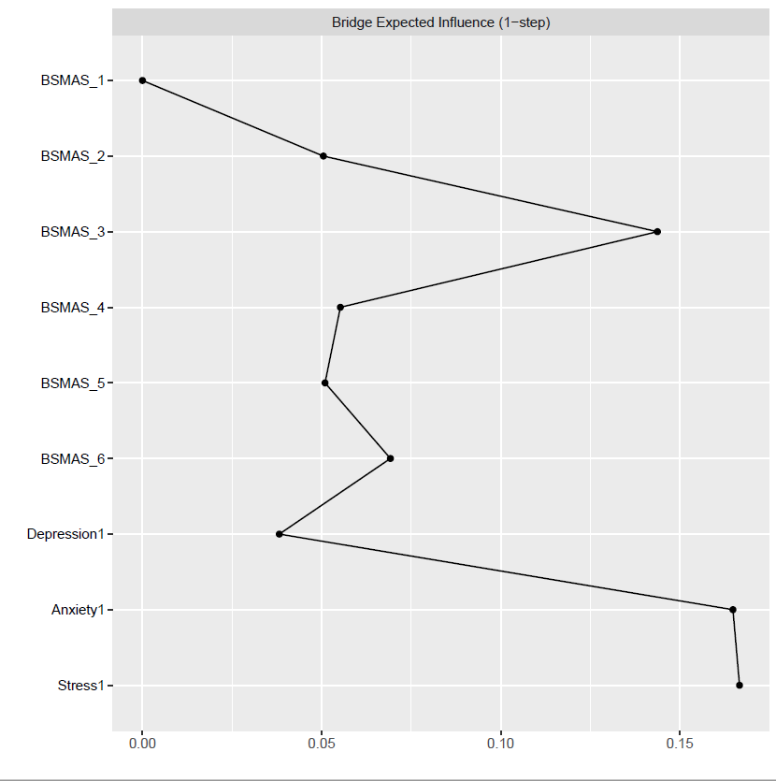

#Create an object for the Stability estimates of bridges

bridgestability1 <- bootnet(network1, boots=1000, type="case", statistics=c("bridgeStrength", "bridgeExpectedInfluence", "bridgeBetweenness", "bridgeCloseness"), communities=groups1)

#get stability coefficients of that networks bridges

corStability(bridgestability1)

Maximum drop proportions to retain correlation of 0.7 in at least 95% of the samples:

bridgeBetweenness: 0.05 (CS-coefficient is lowest level tested)

- For more accuracy, run bootnet(..., caseMin = 0, caseMax = 0.128)

bridgeCloseness: 0

- For more accuracy, run bootnet(..., caseMin = 0, caseMax = 0.05)

bridgeExpectedInfluence: 0.361

- For more accuracy, run bootnet(..., caseMin = 0.284, caseMax = 0.439)

bridgeStrength: 0.128

- For more accuracy, run bootnet(..., caseMin = 0.05, caseMax = 0.206)

Accuracy can also be increased by increasing both 'nBoots' and 'caseN'.

#And we're done with the first Network! Time to move on to number two!

Part 2: Second Time point

#Load data of second network "time_point_2" (I just used haven)

#Assign names to the nodes in the second network

names2 <- c("BSMAS_1_2", "BSMAS_2_2", "BSMAS_3_2", "BSMAS_4_2", "BSMAS_5_2", "BSMAS_6_2", "Depression2", "Anxiety2", "Stress2")

#Estimate network using default methods

network2 <- estimateNetwork(Time_Point_2, default="EBICglasso")

#group DASS and BSMAS nodes

groups2=list("SMA"=c(1:6), "Distress"=c(7:9))

#Estimate Network Stability by bootstrapping network

b3 <- bootnet(network2, boots=1000, statistics=c("strength", "expectedInfluence", "betweenness", "closeness", "edge"))

b4 <- bootnet(network2, boots=1000, type="case", statistics=c("strength", "expectedInfluence", "betweenness", "closeness", "edge"))

#Get centrality stability coefficient

corStability(b4)

Maximum drop proportions to retain correlation of 0.7 in at least 95% of the samples:

betweenness: 0.05 (CS-coefficient is lowest level tested)

- For more accuracy, run bootnet(..., caseMin = 0, caseMax = 0.128)

closeness: 0.128

- For more accuracy, run bootnet(..., caseMin = 0.05, caseMax = 0.206)

edge: 0.749 (CS-coefficient is highest level tested)

- For more accuracy, run bootnet(..., caseMin = 0.673, caseMax = 1)

expectedInfluence: 0.595

- For more accuracy, run bootnet(..., caseMin = 0.517, caseMax = 0.673)

strength: 0.439

- For more accuracy, run bootnet(..., caseMin = 0.361, caseMax = 0.517)

Accuracy can also be increased by increasing both 'nBoots' and 'caseN'.

#Save centrality stability graphs

pdf("CentrStability2.pdf")

plot(b4)

dev.off()

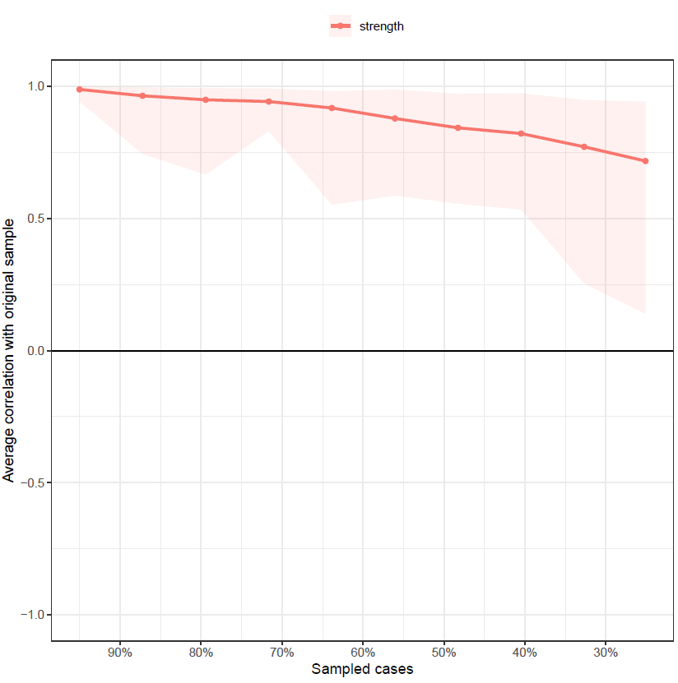

pdf("ExpectStability2.pdf")

plot(b4, “expectedInfluence”)

dev.off()

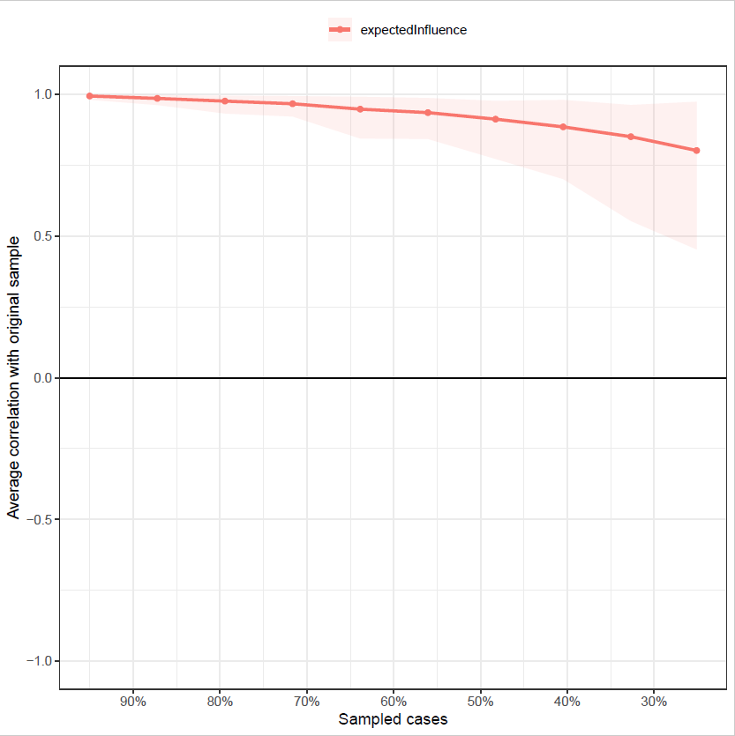

pdf("betweenStability2.pdf")

plot(b4, "betweenness")  
dev.off()

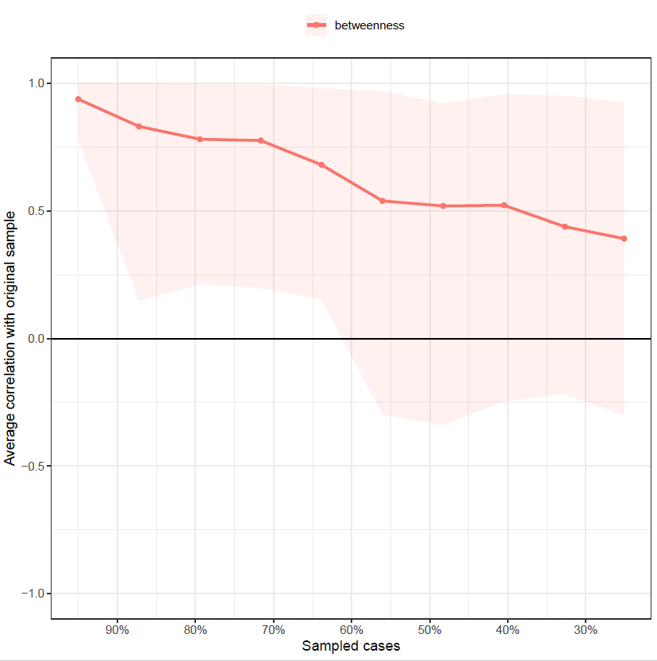

pdf("closeStability2.pdf")

plot(b4, "closeness")

dev.off()

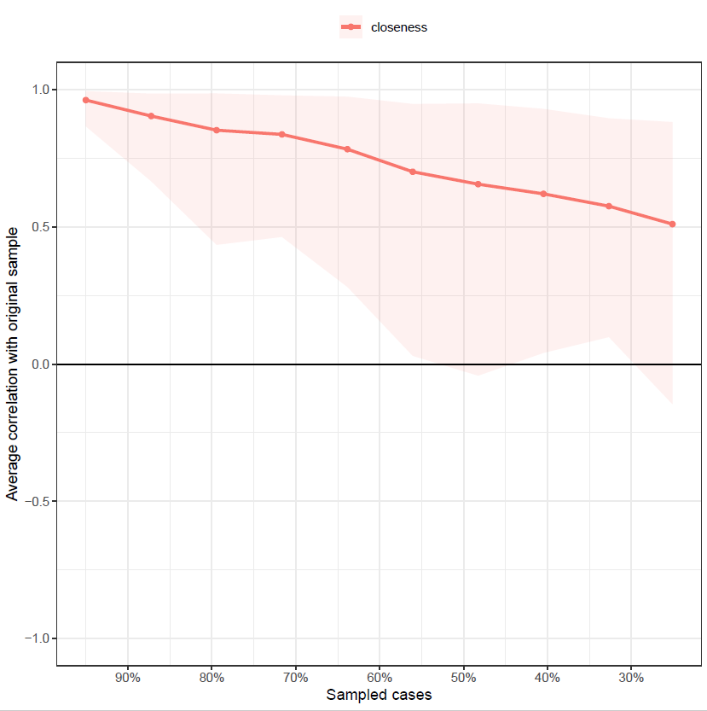

#Strength Centrality Diff Tests, saved as pdf

pdf("CentralityDifference2.pdf")

plot(b3, "strength", order="sample", labels=TRUE)

dev.off()

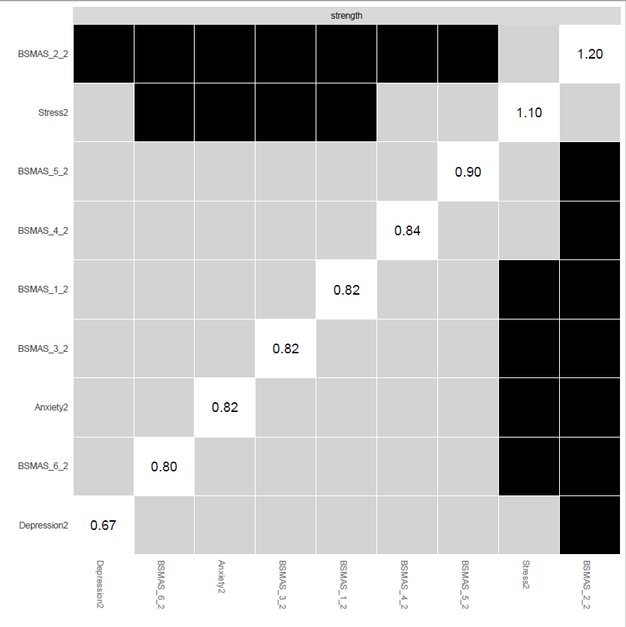

#Expected INfluence stability graph saved as pdf - Unneccessary

pdf("EIdifference2.pdf")

plot(b3, "expectedInfluence", order="sample", labels=TRUE)

dev.off()

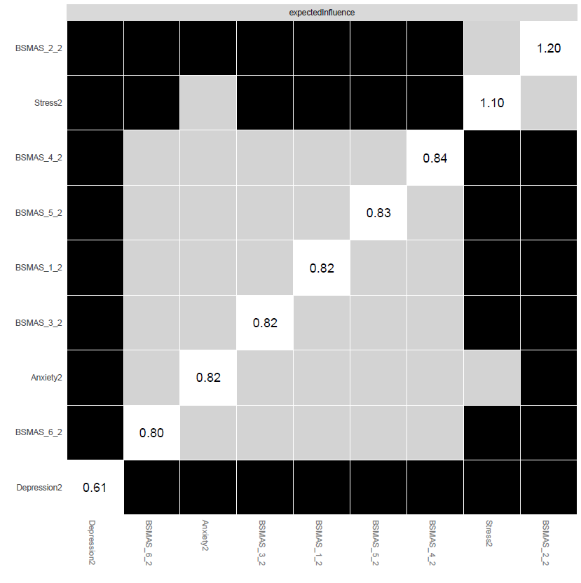

#Edge Stability Graph saved as pdf

pdf("EdgeStability2.pdf")

plot(b3, labels = FALSE, order = "sample")

dev.off()

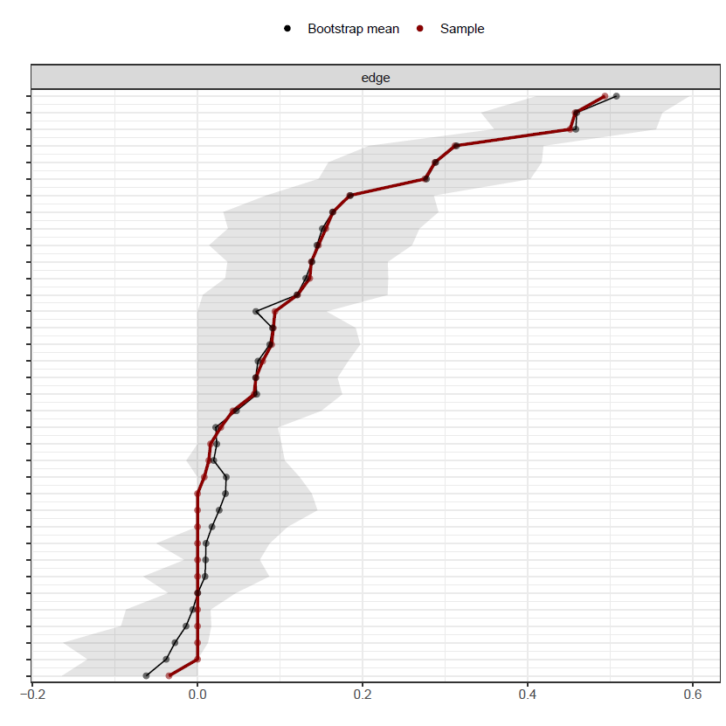

#Edge weights stability test saved as pdf

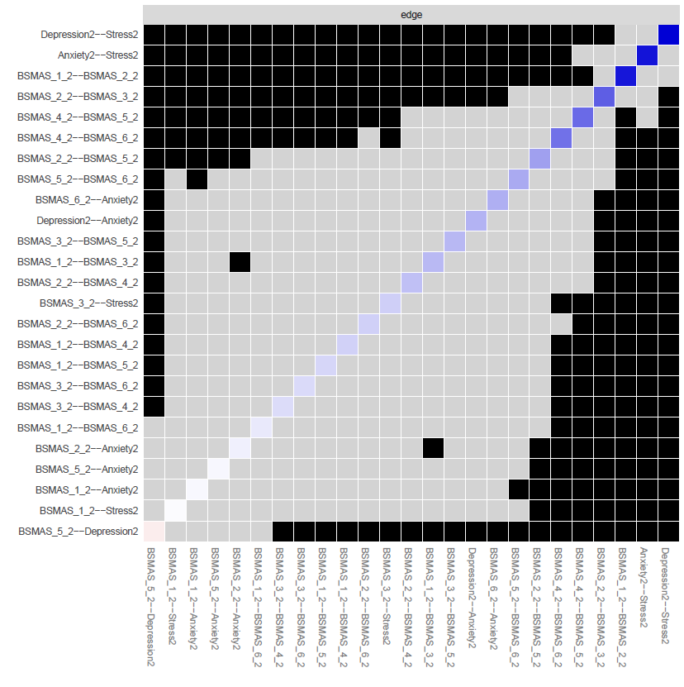pdf("EdgeDifftest2.pdf")

plot(b3, "edge", plot="difference", onlyNonZero=TRUE, order = "sample")

dev.off()

#Save plot as a pdf with groups into set directory

pdf("plot2.pdf")

plot2 <- plot(network2, layout="spring", vsize=6, border.color="black", groups=groups2, color=c('lightblue', 'orange'))

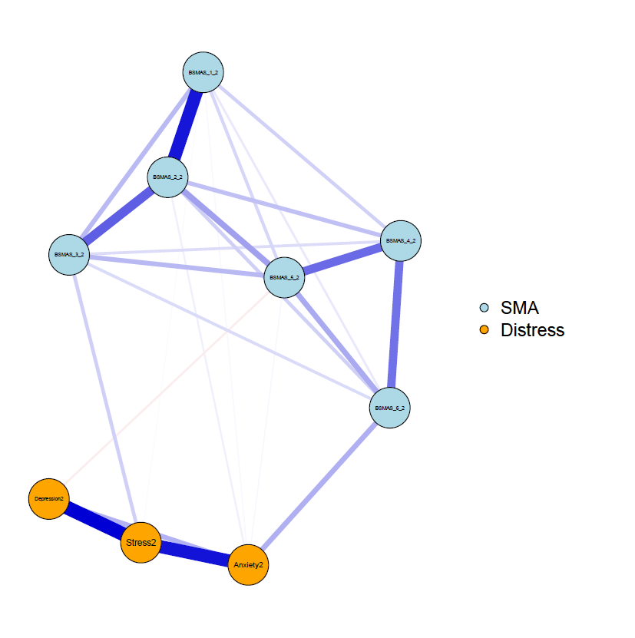dev.off()

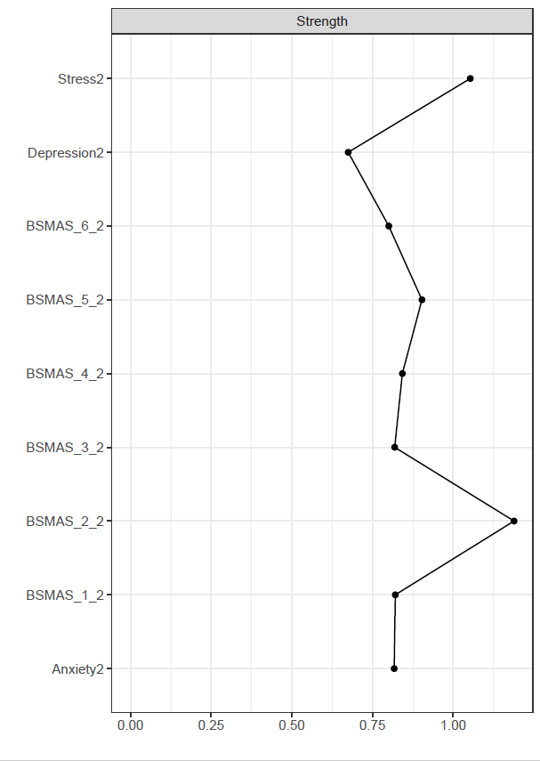

#create centrality plot and save as pdf

pdf("CentralityPlot2.pdf", width=5)

c2 <- centralityPlot(plot2)

dev.off()

#Create Expected influence plot and save as pdf (Unnecessary given the lack of negative edges)

pdf("ExpectedInfluence2.pdf", width=5)

e2 <- centralityPlot(plot2, include = "ExpectedInfluence")

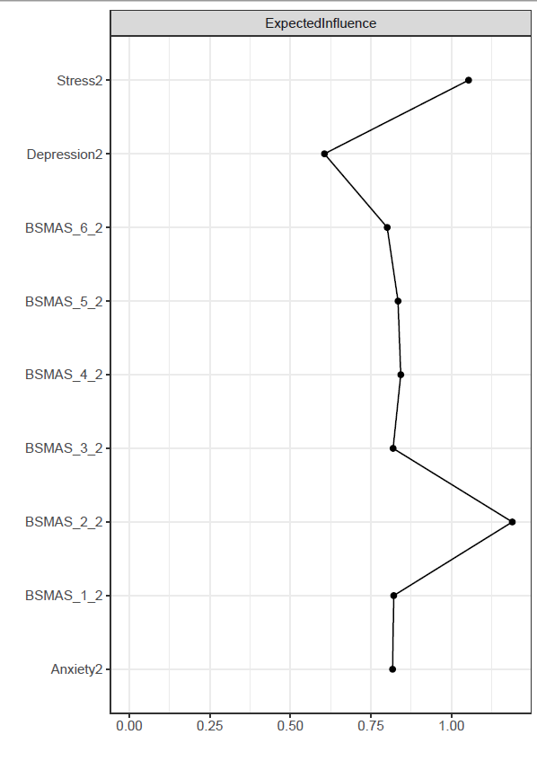dev.off()

#Create Betweenness/Closeness plot and save as a pdf.

pdf("BetClosePlot2.pdf", width=5)

c3 <- centralityPlot(network2, include = c("Betweenness", "Closeness"), orderBy ="default")

dev.off()

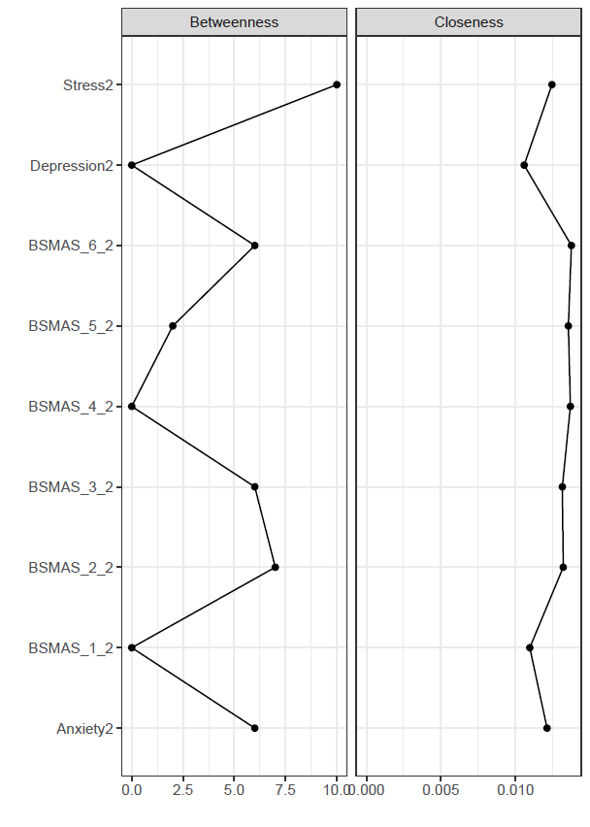

#save centrality values as a excel file

Centrality2 <- centralityTable(network2)

write.csv(Centrality2, "Centrality2.csv")

|  |  |  |  |  |  |
| --- | --- | --- | --- | --- | --- |
|  | graph | type | node | measure | value |
| 1 | graph 1 | NA | BSMAS_1_2 | Betweenness | -1.114326414 |
| 2 | graph 1 | NA | BSMAS_2_2 | Betweenness | 0.783040183 |
| 3 | graph 1 | NA | BSMAS_3_2 | Betweenness | 0.511987812 |
| 4 | graph 1 | NA | BSMAS_4_2 | Betweenness | -1.114326414 |
| 5 | graph 1 | NA | BSMAS_5_2 | Betweenness | -0.572221672 |
| 6 | graph 1 | NA | BSMAS_6_2 | Betweenness | 0.511987812 |
| 7 | graph 1 | NA | Depression2 | Betweenness | -1.114326414 |
| 8 | graph 1 | NA | Anxiety2 | Betweenness | 0.511987812 |
| 9 | graph 1 | NA | Stress2 | Betweenness | 1.596197295 |
| 10 | graph 1 | NA | BSMAS_1_2 | Closeness | -1.396869146 |
| 11 | graph 1 | NA | BSMAS_2_2 | Closeness | 0.508729775 |
| 12 | graph 1 | NA | BSMAS_3_2 | Closeness | 0.459210954 |
| 13 | graph 1 | NA | BSMAS_4_2 | Closeness | 0.91689085 |
| 14 | graph 1 | NA | BSMAS_5_2 | Closeness | 0.802006798 |
| 15 | graph 1 | NA | BSMAS_6_2 | Closeness | 0.975192048 |
| 16 | graph 1 | NA | Depression2 | Closeness | -1.719301563 |
| 17 | graph 1 | NA | Anxiety2 | Closeness | -0.412917999 |
| 18 | graph 1 | NA | Stress2 | Closeness | -0.132941717 |
| 19 | graph 1 | NA | BSMAS_1_2 | Strength | -0.38745599 |
| 20 | graph 1 | NA | BSMAS_2_2 | Strength | 2.020368632 |
| 21 | graph 1 | NA | BSMAS_3_2 | Strength | -0.400100669 |
| 22 | graph 1 | NA | BSMAS_4_2 | Strength | -0.244664219 |
| 23 | graph 1 | NA | BSMAS_5_2 | Strength | 0.152560743 |
| 24 | graph 1 | NA | BSMAS_6_2 | Strength | -0.520323986 |
| 25 | graph 1 | NA | Depression2 | Strength | -1.342250577 |
| 26 | graph 1 | NA | Anxiety2 | Strength | -0.41102991 |
| 27 | graph 1 | NA | Stress2 | Strength | 1.132895977 |
| 28 | graph 1 | NA | BSMAS_1_2 | ExpectedInfluence | -0.264649472 |
| 29 | graph 1 | NA | BSMAS_2_2 | ExpectedInfluence | 1.957052496 |
| 30 | graph 1 | NA | BSMAS_3_2 | ExpectedInfluence | -0.27631673 |
| 31 | graph 1 | NA | BSMAS_4_2 | ExpectedInfluence | -0.132895376 |
| 32 | graph 1 | NA | BSMAS_5_2 | ExpectedInfluence | -0.18422989 |
| 33 | graph 1 | NA | BSMAS_6_2 | ExpectedInfluence | -0.387246894 |
| 34 | graph 1 | NA | Depression2 | ExpectedInfluence | -1.563493654 |
| 35 | graph 1 | NA | Anxiety2 | ExpectedInfluence | -0.28640115 |
| 36 | graph 1 | NA | Stress2 | ExpectedInfluence | 1.13818067 |

#construct a partial correlation matrix

edges2<-getWmat(network2)

write.csv(edges2, "edges2.csv")

|  |  |  |  |  |  |  |  |  |  |
| --- | --- | --- | --- | --- | --- | --- | --- | --- | --- |
|  | BSMAS_1_2 | BSMAS_2_2 | BSMAS_3_2 | BSMAS_4_2 | BSMAS_5_2 | BSMAS_6_2 | Depression2 | Anxiety2 | Stress2 |
| BSMAS_1_2 | 0 | 0.451503 | 0.135943 | 0.089733 | 0.078881 | 0.042888 | 0 | 0.013695 | 0.008121 |
| BSMAS_1_2 | 0 | 0.451503 | 0.135943 | 0.089733 | 0.078881 | 0.042888 | 0 | 0.013695 | 0.008121 |
| BSMAS_2_2 | 0.451503 | 0 | 0.311908 | 0.121204 | 0.184355 | 0.091791 | 0 | 0.028163 | 0 |
| BSMAS_3_2 | 0.135943 | 0.311908 | 0 | 0.068454 | 0.137948 | 0.070743 | 0 | 0 | 0.093834 |
| BSMAS_4_2 | 0.089733 | 0.121204 | 0.068454 | 0 | 0.28772 | 0.275486 | 0 | 0 | 0 |
| BSMAS_5_2 | 0.078881 | 0.184355 | 0.137948 | 0.28772 | 0 | 0.164086 | -0.03462 | 0.015722 | 0 |
| BSMAS_6_2 | 0.042888 | 0.091791 | 0.070743 | 0.275486 | 0.164086 | 0 | 0 | 0.155455 | 0 |
| Depression2 | 0 | 0 | 0 | 0 | -0.03462 | 0 | 0 | 0.146503 | 0.49365 |
| Anxiety2 | 0.013695 | 0.028163 | 0 | 0 | 0.015722 | 0.155455 | 0.146503 | 0 | 0.457623 |
| Stress2 | 0.008121 | 0 | 0.093834 | 0 | 0 | 0 | 0.49365 | 0.457623 | 0 |

#Estimate bridge Values for each node

bridge(plot2, communities=c('1', '1', '1', '1', '1', '1', '2', '2', '2'), useCommunities = "all", directed = NULL, nodes = NULL)

$`Bridge Strength`

BSMAS_1_2 BSMAS_2_2 BSMAS_3_2 BSMAS_4_2 BSMAS_5_2 BSMAS_6_2

0.02181621 0.02816251 0.09383429 0.00000000 0.05034308 0.15545455

Depression2 Anxiety2 Stress2

0.03462147 0.21303384 0.10195534

$`Bridge Betweenness`

BSMAS_1_2 BSMAS_2_2 BSMAS_3_2 BSMAS_4_2 BSMAS_5_2 BSMAS_6_2

0 3 6 0 0 6

Depression2 Anxiety2 Stress2

0 6 9

$`Bridge Closeness`

BSMAS_1_2 BSMAS_2_2 BSMAS_3_2 BSMAS_4_2 BSMAS_5_2 BSMAS_6_2

0.05720293 0.06550162 0.08291373 0.08200252 0.06821670 0.11675703

Depression2 Anxiety2 Stress2

0.06792650 0.07876455 0.07876455

$`Bridge Expected Influence (1-step)`

BSMAS_1_2 BSMAS_2_2 BSMAS_3_2 BSMAS_4_2 BSMAS_5_2 BSMAS_6_2

0.02181621 0.02816251 0.09383429 0.00000000 -0.01889985 0.15545455

Depression2 Anxiety2 Stress2

-0.03462147 0.21303384 0.10195534

$`Bridge Expected Influence (2-step)`

BSMAS_1_2 BSMAS_2_2 BSMAS_3_2 BSMAS_4_2 BSMAS_5_2 BSMAS_6_2

0.06846299 0.09507907 0.20323628 0.04918203 0.01379987 0.25642629

Depression2 Anxiety2 Stress2

0.01738713 0.41192804 0.25687137

#Set Bridge estimates as an object

bridge2 <- bridge(plot2, communities=c('1', '1', '1', '1', '1', '1', '2', '2', '2'), useCommunities = "all", directed = NULL, nodes = NULL)

#Create bridge expected influence graph and save as a pdf

pdf("bridgeEI2.pdf, width=5")

plot(bridge2, include = "Bridge Expected Influence (1-step)", width = 5)

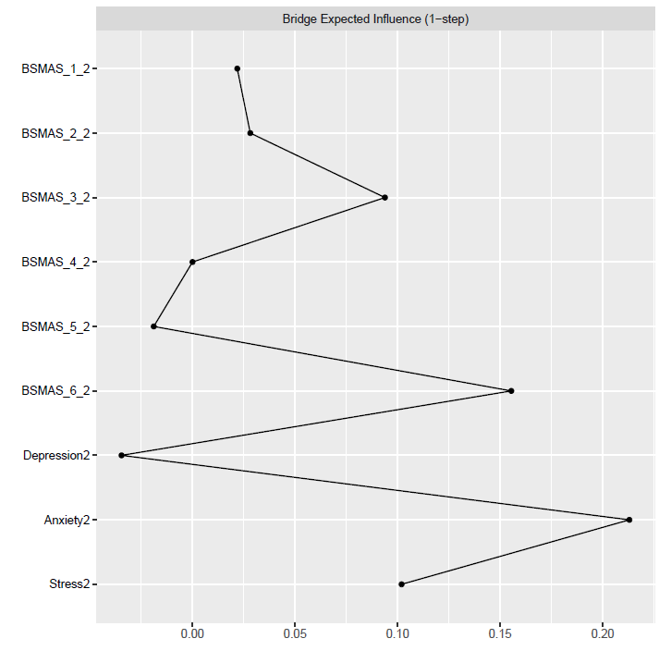dev.off()

#Create an object for the Stability estimates of bridges

bridgestability2 <- bootnet(network2, boots=1000, type="case", statistics=c("bridgeStrength", "bridgeExpectedInfluence", "bridgeBetweenness", "bridgeCloseness"), communities=groups2)

#get stability coefficients of that networks bridges

corStability(bridgestability2)

Maximum drop proportions to retain correlation of 0.7 in at least 95% of the samples:

bridgeBetweenness: 0.05 (CS-coefficient is lowest level tested)

- For more accuracy, run bootnet(..., caseMin = 0, caseMax = 0.128)

bridgeCloseness: 0.284

- For more accuracy, run bootnet(..., caseMin = 0.206, caseMax = 0.361)

bridgeExpectedInfluence: 0.517

- For more accuracy, run bootnet(..., caseMin = 0.439, caseMax = 0.595)

bridgeStrength: 0.128

- For more accuracy, run bootnet(..., caseMin = 0.05, caseMax = 0.206)

Accuracy can also be increased by increasing both 'nBoots' and 'caseN'.

Part 3: Comparison

#Now let's compare the two networks we've created.

#Omit missing data from datasets

newdata1 <- na.omit(Time_Point_1)

newdata2 <- na.omit(Time_Point_2)

#Create names for nodes in the networks

names1 <- c("BSMAS_1", "BSMAS_2", "BSMAS_3", "BSMAS_4", "BSMAS_5", "BSMAS_6", "Depression1", "Anxiety_1", "Stress1")

names2 <- c("BSMAS_1_2", "BSMAS_2_2", "BSMAS_3_2", "BSMAS_4_2", "BSMAS_5_2", "BSMAS_6_2", "Depression2", "Anxiety2", "Stress2")

#Estimate networks from these new datasets

networkc1 <- estimateNetwork(newdata1, default="EBICglasso")

networkc2 <- estimateNetwork(newdata2, default="EBICglasso")

#Run the NCT on these two networks

Comparison <- NCT(networkc1, networkc2, it=1000, weighted = TRUE, test.edges = FALSE, edges='ALL')

#Get the results of your NCT

summary(Comparison)

NETWORK INVARIANCE TEST

Test statistic M: 0.196435

p-value 0.338

GLOBAL STRENGTH INVARIANCE TEST

Global strength per group: 4.107358 3.903432

Test statistic S: 0.2039267

p-value 0.415

EDGE INVARIANCE TEST

Edges tested:

Test statistic E:

p-value

CENTRALITY INVARIANCE TEST

Nodes tested:

Centralities tested:

Test statistic C:

p-value